

**University of Information Technology and Sciences** (***UITS***)

Department of Computer Science and Engineering

Project Proposal

**Course Code:** CSE 312

**Course Title:** Artificial Intelligence Lab

**Submitted To:**

**Ratri Datta**

lecturer

Department of CSE

University of information technology and sciences

**Submitted By:**

**Name**: ***MD. Shahanawas Ali Shuvo***

s**tudent ID:** 0432410005101100

Section: 5C2

Department: CSE

Email: alishuvo143@gmail.com

Date : 27.04.2024

**Title:** Bash ATM System with Enhanced Features

**Introduction:**

In this project, we propose the development of a Bash ATM system with enhanced features to provide users with a more secure, efficient, and versatile banking experience. Traditional ATM systems often lack advanced functionalities and may not prioritize security adequately. By leveraging the simplicity and flexibility of Bash scripting, we aim to create an ATM system that not only facilitates basic banking operations but also incorporates additional features for improved user interaction and security.

**Objectives or Aims:**

1. To create a user-friendly ATM system using Bash scripting.

2. To implement advanced features such as transaction history tracking and PIN change functionality.

3. To ensure security by adopting best practices for handling sensitive information such as PINs.

4. To provide a comprehensive and reliable banking experience within the constraints of a command-line interface.

**Key Features:**

1. PIN Security: The system employs a predefined PIN for user authentication, which can be changed by the user for enhanced security.

2. Transaction History: The ATM system maintains a record of all transactions, allowing users to review their recent activity.

3. Balance Inquiry: Users can easily check their account balance at any time during their interaction with the ATM.

4. Withdrawal and Deposit: Basic banking operations such as withdrawal and deposit are supported, with proper validation and error handling.

5. Intuitive Interface: The ATM system provides a simple and intuitive command-line interface for users to navigate through various options effortlessly.

**Result and Discussion:**

The Bash ATM system was successfully implemented with the specified features. Users can interact with the system to perform banking operations, view transaction history, and change their PIN for added security. The system's simplicity and functionality make it suitable for individuals seeking a basic yet effective banking solution. Below is a screenshot demonstrating the system's interface:

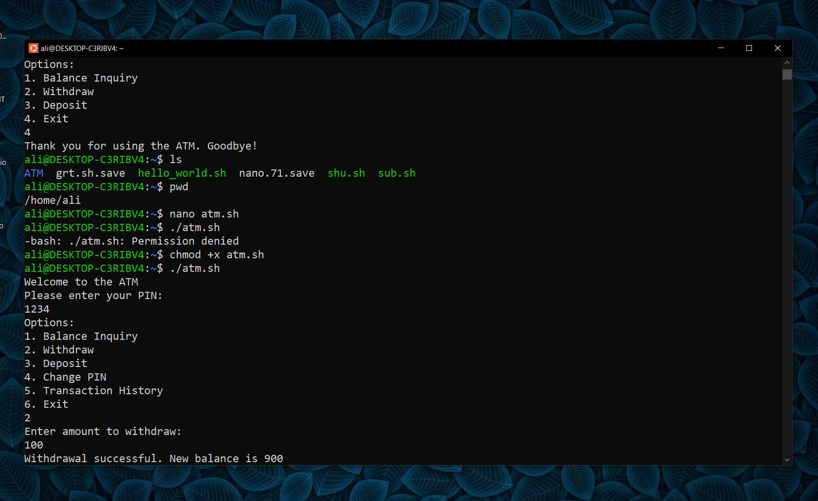Figure 1: Screenshot of the Bash ATM System Interface

**Conclusion:**

In conclusion, the development of the Bash ATM system with enhanced features has met the project's objectives. The system provides users with a convenient and secure means of conducting banking transactions within a command-line environment. Future enhancements may include support for additional banking operations, improved error handling, and integration with external databases for data persistence.

**Script Features:**

The script for the Bash ATM system, along with its enhanced features, is available on GitHub for review and collaboration. The repository includes comprehensive documentation and instructions for usage. You can access the project repository [here]( https://github.com/Alishuvo/Bash-ATM-System-with-Enhanced-Features.git).

This project proposal outlines the development of a Bash ATM system with advanced features, aiming to enhance user experience and security in banking transactions conducted through a command-line interface.